Music ideas for the summer holidays 2020
- Try listening to a new music style: Did you enjoy it? What instruments could you hear? What kind of tempo was it? Did the music change during the piece, if so how? What did you like/not like about it? Would you listen to more music in this style?

- Create your own instruments out of junk, can you make different kinds of instruments that you play in different ways? E.g. tapping, shaking, plucking, blowing?

- Choose a song/piece of music and make up your own dance to go with it.

- Look at the lyrics in a favourite song and have a go at writing your own verse.

- Create your own playlist for a disco, think about which songs fit well together, whether you will have a change in mood e.g. some fast, some slow songs – if you have all the songs available you could have your own disco with your family.

- Listen to a song/piece of music and create some artwork that reflects what you think of when you listen to it.

- Choose a musical to watch with your family, if there is a singalong version, try it out!

- Research a favourite musical artist – what interesting facts can you find out about them?

- Check out these websites for lots more music learning and activities:
https://www.bbc.co.uk/teach/ten-pieces
https://www.classicsforkids.com/

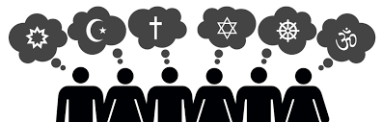
Faith ideas for the summer holidays 2020
- All religions have special festivals, have a go at designing your own festival. What will it be celebrating? What date/time of year will it be? What will the special clothes, dance, decorations, food be? Will there be any important things people must do?

- Research special food for a religious festival (e.g. Diwali, eid-ul-fitr, Hanukkah). Is there a dish you can have a go at making?
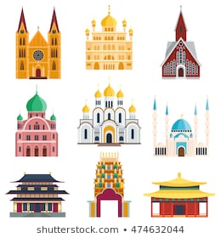

- Find out what places of worship there are in the local area (for any religion). Maybe visit some if you can and notice some of features of them.

- Find out about the place of worship for a religion (a church, synagogue, mosque, hindu temple. Research what they include, what special customs do they practise, can you design your own version, maybe make a 3D model of it?

- Most religions have important rules that their members must try to follow. Can you make up your own set of rules for the summer holidays? Make sure they are safe to follow!

- Most religions teach about treating others as we would want to be treated, acts of good deeds and loving each other. Can make a list/poster of good deeds you would be able to do to help others (remember these can be simple things like saying kind words, or tasks that would help around the house.) Have a go at doing as many as you can, you will be amazed at how good it makes you feel as well as cheering someone else up!

- How many of the symbols at the top of the page do you recognise? Can you find out which religion uses each symbol?

- Check out https://www.youtube.com/playlist?list=PLcvEcrsF_9zK0q_Ey3yl7k5LA5v1M7NNs for lots of interesting clips about different religions.

