MINDFULLNESS AND WELLBEING IDEAS
FOR SUMMER HOLIDAYS 2020
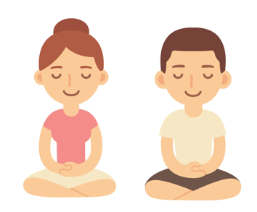

- A picture book for children worried about the Coronavirus:
https://en.calameo.com/read/000777721945cfe5bb9cc?authid=Xu9pcOzU3TQx

- Mindfulness:
Mindfulness colouring is a relaxing and calming activity which can also encourage children to explore their creativity while improving fine motor skills!
Colouring in pages:
https://www.teachingideas.co.uk/2d-art/mindfulness-colouring-images-animals
https://www.bestcoloringpagesforkids.com/mindfulness-coloring-pages.html
A five or ten-minute daily mindfulness practice can help to reduce stress and anxiety.
5-10 minute activities:
https://www.teachstarter.com/gb/blog/classroom-mindfulness-activities-for-children-gb/

- Meditation:
Meditation can help to regulate children’s emotions as well as improve concentration and focus.
https://annakaharris.com/mindfulness-for-children/

- Self-esteem:
Self-esteem helps children cope with mistakes and build their resilience. It helps them try again, even if they fail at first. As a result, self-esteem will help them do better at school, at home, and with friends. Children with low self-esteem feel unsure of themselves, so improving self-esteem, improves confidence.
http://www.plantlovegrow.com/self-esteem.html
https://www.kidsplayandcreate.com/self-esteem-character-building-activities-for-kids/

- Self-care:
Self-care is about the things that we can do to look after our own mental health.
https://www.annafreud.org/on-my-mind/self-care/
https://www.childline.org.uk/toolbox/calm-zone/

- Yoga:
Yoga helps children to boost confidence. Regular practicing of yoga helps your child to grow self-confidence.
https://www.cosmickids.com/

