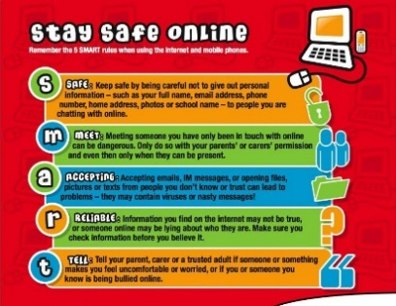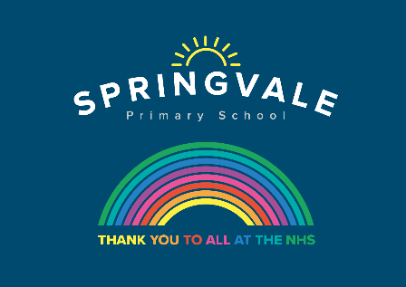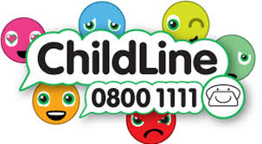
W/C 6.07.2020: Learning Project - Music
Age Range: Y5/6 Mrs Henstock/Mrs Fearne/Mrs Mayston
Weekly Reading Tasks | Weekly Spelling Tasks
Monday- During your child’s daily reading, play some classical music, rock music, jazz music and pop music. Ask your child to draw an emoji to represent how each music genre made them feel whilst they were reading. | Monday- Pick 5 Common Exception words from the Year 5/6 spelling list. Play a song and stop it at different points. When it stops, one spelling should be selected from a bag and your child must spell it before the music starts again.
Tuesday- Ask your child to find the lyrics to their favourite song and to create some new verses. Can they perform the new verses to the family? | Tuesday- The word rhythm has a silent letter - what other words can your child spell which also have silent letters?
Wednesday- Click here for a reading activity about Music. Challenge your child to read the text in 3 minutes and complete the questions. | Wednesday- Practise spellings on Spelling Frame or practise spelling words with silent letters on this game.
Thursday- Your child can listen or read along to the poem Cat Rap here. Can they write their own version using a different noisy animal? | Thursday- Using the letters C A R N I V A L, task your child with listing associated adjectives or verbs that correspond with each letter.
Friday- Visit Audible and let your child choose a book to listen to. Ask them to write a review when they have finished and share it with a friend (remotely). | Friday- Can your child create a musical glossary for the following vocabulary: dynamics, structure, timbre, texture & tempo.
Weekly Writing Tasks | Weekly Maths Tasks- Shape and Angles
Monday- Visit the Literacy Shed for this wonderful resource on Once in a Lifetime or take part in a writing master class. | Monday- Work with your child to find the missing angle in the triangles or around a point.
Tuesday- Listen to A Night on Bare Mountain by Modest Mussorgsky and the inspiration behind it. Ask your child to create a story with the same title that could be told along with the music. | Tuesday- Ask your child to draw a map from their bedroom to the kitchen. Calculate the total degrees of turn involved on the journey. They can repeat this activity for other areas in your home or for their daily walk.
Wednesday- Ask your child to create an information booklet about two pieces of music they have listened to. Include information about the instruments they have heard within each piece and a brief history on the musicians. | Wednesday- Encourage your child to look for and collect 3D objects around the home. For the ones they have selected, get them to name the 3D shape, list the properties (the number of edges, faces and vertices) and draw the net to match.
Thursday- Ask your child to change the lyrics of their favourite song into a short story. Alternatively, they could write and perform their own song. | Thursday- Get your child to practise measuring and reading angles with a protractor with this online game.
Friday- Listen to 'Toccata and Fugue in D Minor'. Ask your child to think about what the setting might be and describe the atmosphere. Ask them to create two characters and think about what could be happening. Get them to write a short play script/ piece of dialogue between the characters that would go with this music. | Friday (theme)- Ask your child to create a rhythm by clapping/clicking, e.g. clap, clap, clap, click, clap, clap, clap, click etc. Ask your child to predict what action they would do on the 15th beat. Can they work it out without having to do the rhythm? What about the 20th, 50th, 99th beat? Do they notice any patterns?

Learning Project - to be done throughout the week
The project this week aims to provide opportunities for your child to learn more about music. Learning may focus on famous musicians, listening to and performing music and exploring a range of music genres and instruments.

- Sound Effects- Many audio books use sound effects to enhance the retelling of books. Ask your child to think about a narrative that they are currently reading or have read recently. What sound effects would enhance the retelling of the story? Ask your child to source a range of props to help add sound effects and record the retelling of the story with their sound effects. Remember to tweet a video of their retelling.

- Carnival Time-The Rio carnival is a spectacle of samba, costumes and dance and takes place every year. Here are some of the pictures from this year’s parade. Challenge your child to research the samba inspired costumes and headdresses worn during the parades. Ask them to design, label and make their own mask or headdress taking inspiration from the research completed.

- Expression- Kandinsky felt that he could express emotions and music through colours and shapes within his painting. Ask your child to create a piece of artwork inspired by their favourite piece of music. Encourage them to listen to the music several times and feel free to draw or paint the emotion they feel at the time.
- Making Instruments
A kazoo is a simple wind instrument that allows the player to create sound by humming.
You will need a cardboard tube, square of grease proof paper and an elastic band. Cover the end of the tube in paper and secure it in place using the elastic band.
Hum a tune into the open end of the kazoo. What happens to the kazoo? What happens to the sound of your voice?

Learn more about sound by researching how ears work and different ears are adapted to different environments. Find out why elephants have such big ears.
For more ideas take a look at the full resources here.

- Music Video Directors- Using the song your child created for their writing task this week, direct them to think about the sort of music video that they could create to go with it. They could storyboard their ideas and think about whether they need any props or even come up with a dance routine before recording it.

- More Musical Activities
Visit https://www.bbc.co.uk/teach/ten-pieces for lots of different pieces of music to listen to and learn about.
Visit https://www.classicsforkids.com/ for learning and games about different types of instruments and music.

- Family Time
Listen Together - Encourage your child to ask each family member what their favourite song is. Play the song aloud and listen together. Spend some time as a family discussing what genre of music the songs belong to and how each piece of music makes you feel. Which genres of music were the most popular? Can your child represent their results in a bar chart? They could ask family members to rank their favourite genres of music first.

Musical Movie Time - Allow your child to choose an age-appropriate musical to watch. Andrew Lloyd Webber is now posting filmed versions of his shows on his Youtube channel The Shows Must Go On! each week! Discuss the story behind the musical and ask your child to step into the shoes of different characters and imagine how they are feeling. Which is your child’s favourite song from the film/show and why? Can they create a billboard poster advertising the show? Or perhaps design a ticket?

Additional learning resources parents may wish to engage with
- BBC Bitesize - Lots of videos and learning opportunities for all subjects.
- Classroom Secrets Learning Packs - Reading, writing and maths activities for different ages.
- White Rose Maths online maths lessons. Watch a lesson video and complete the worksheet (can be downloaded and completed digitally).
- Times Table Rockstars. Your child can access both this programme with their school logins. Children should aim to play Soundcheck for 20 minutes daily.
- Mastery Mathematics Learning Packs. Take a look at the mastery mathematics home learning packs with a range of different activities and lessons.
Y5 Talk for Writing Home-school Booklets and Y6 are an excellent resource to support your child’s speaking and listening, reading and writing skills.

Stay safe. We miss you.
@SpringvalePS

