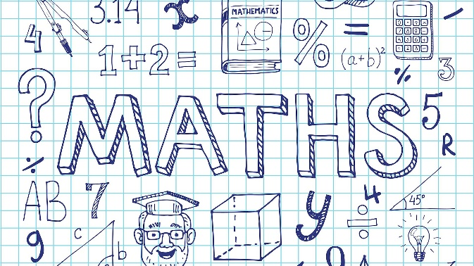
Summer maths trail fun
use the clues to hunt for the answers around the local area
suitable for all families!!
see separate “maths trail” document

Nim-7 for Two Ages 5 to 14
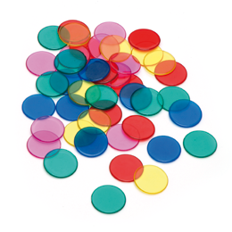
Here’s a game to play with an adult! This is a basic form of the ancient game of Nim.
How do you play?
You'll need an adult to play with.
You will also need seven objects, such as counters or blocks.
Place the 7 counters in a pile and starting with the adult, take turns to take away either one or two counters.
The person who takes the last counter wins.
Swap who goes first, and keep playing until you work out a winning strategy.
Does it matter who has the first turn?
What happens when there are three counters left?
How can you win at this game?
What happens when you start the game with more counters?

Other great games and ideas (not interactive; but instructions and examples on the links)
Strike it out for two… https://nrich.maths.org/10091
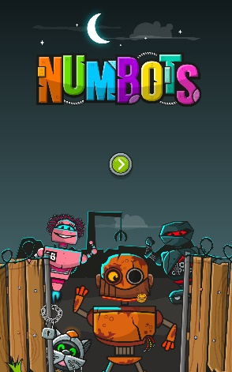
Totality for two (need a printer) https://nrich.maths.org/11114
How many? Look at these pictures and guess how many…then see if you can use your method to count things around you…maybe leaves on trees? Crisps in a packet? Pages in a book? Did you get close? What methods did you use? https://nrich.maths.org/14404/note
*Remember - keep up with Numbots and Ttrockstars!

