Monday 5th October 2020
Dear Class... How are you all? I hope you are all staying safe and well. Remember you are not to leave your home until we return to school on Friday---WIPPEE
Remember... Kindness is paramount! Think about your words and deeds carefully...we can add them into our kindness box as we return to school. I can’t wait to see you all...Remember Friday is swimming, so bring your stuff!
So what have I included this week? A Quest and an investigation..Lots to keep your brain alert and busy! I am attaching a daily schedule for you all and on the school website are more home learning activities...and keep active...find fun ways to keep fit indoors!
TTrockstars result (Y6 Boys v Girls)....well girls...I’m a bit gutted! But hey-well done boys-AWESOME JOB! You will get a reward for your super efforts!
MON
Practise spellings (make sure you are being tested )
TT rockstars 2x 15 mins-
Read own book 30-45 mins- make sure your log is up to date!
GPS- we have been set a quest...
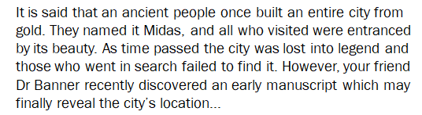
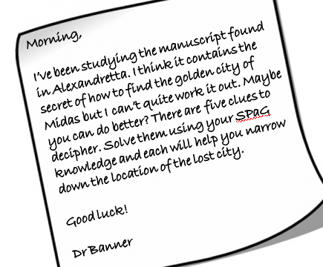

Finding Midas clues 1 and 2...follow the instructions carefully to reveal the first and second clues
Maths session 9 factors
IT- start scratch project. Create a spooky setting and a spooky character that moves. Look at fade/ disappear and react functions.
Physical activity 3x 20mins
Use these links for workouts ...apologies they are a little annoying! But GREAT https://www.youtube.com/watch?v=5if4cjO5nxo
https://www.youtube.com/watch?v=pwdb6m4gYmQ
https://www.youtube.com/watch?v=FB5-7tIiX-I

TUES
Practise spellings
TT rockstars 2x 15 mins-
GPS- finding Midas clue 3 to reveal...follow instructions very carefully
Reading- this week we are looking at texts about drugs and alcohol as this is our Science focus- how to stay healthy- the first one is the risk factors of smoking:
https://www.bhf.org.uk/informationsupport/risk-factors/smoking
Questions:
https://docs.google.com/presentation/d/1tLpA6sCpA3yz4YyA-N1qiZKx4ZLSyOWdFDBo_vZ095I/edit#slide=id.p
Maths – session 10 multiples
Science- Investigation- heart rate- take your resting pulse-make a note of it- this is how many beats your heart does in a minute! (watch youtube clip to help https://www.youtube.com/watch?v=tF9-jLZNM10 )
Now do 2 mins of an exercise...take your pulse again...note it down...sit down...when does your pulse go back to resting rate? Make a note
Now do a different exercise for 2 mins...what is the rate now?
Repeat and make notes of what you notice. If you can try and compare this with another member of your household. What do you notice? which exercise made your heart beat fastest? Was it the same for both of you?
Physical activity 3x 20mins

WEDS
Practise spellings
TT rockstars 2x 15 mins-
GPS- Midas clue 4...what will it reveal today?
Reading- text 2- stories from former smokers:
https://60plus.smokefree.gov/support/stories-former-smokers
Questions : https://docs.google.com/presentation/d/1lKU0GspeveKXscI8OW-QlSNE98mzX_3b5CHg60jauxQ/edit#slide=id.p
Maths – session 11 primes
IT- Scratch project- add another character and complete a scene with the spooky theme. Can you fade one in and out? Make sure they are reacting to each other.
Physical activity 3x 20mins
THURS
Practise spellings- test for real tomorrow!
TT rockstars 2x 15 mins-
GPS- finding Midas clue 5...the final clue....bring ALL the clues with you tomorrow to reveal the destination and if you are successful you will receive a reward!!! (not gold)
Reading- logs will be checked tomorrow!
Text 3- lyrics from old red eyes is back- listen to the song-
Song on youtube: https://www.youtube.com/watch?v=t7CLmSJzDYk
Lyrics : https://www.azlyrics.com/lyrics/beautifulsouth/oldredeyesisback.html
Questions: https://docs.google.com/presentation/d/1rfWaVX2Dp4hn8pQc23XGW6QRjtU9NkrenRg0wV0ceok/edit#slide=id.p
Maths – session 12 squares and cubes
Topic...DT... research a shaduf...what was it used for? Draw and label your own design. If you have materials please make one using play doh (or similar), and straws and card. Bring photo or email to me...
Physical activity 3x 20mins
So see you ALL Friday-which is with Mrs Fearn/Mr McClure!!!
Bring spelling book/ reading log/ homework(long multiplication and other stuff from home?)/ swimming kit/ Midas clues
Take care
Mrs Mayston
r.mayston@springvaleprimary.org

