Springvale Primary School
Pupil Premium Projected Spending 2021-22
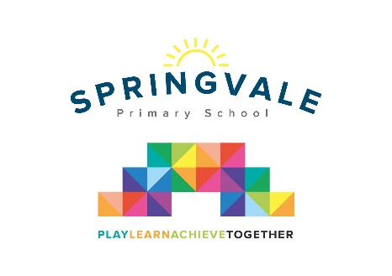
Pupil Premium funding is allocated to schools by the government to support children who fall into vulnerable groups. It is for schools to decide how the funding is spent, and careful consideration should be made, taking into account the various needs of the children eligible for this funding. We endeavor to ensure that our funding is used to support all eligible pupils in making at least good academic progress each school year.
At Springvale Primary, in terms of Pupil Premium children, we currently have 27 (and 2 Early Years Pupil Premium) as follows:

- 23 FSM F2-Y6
- 2 FSM Ever6
- 1 Service Child
- 1 LAC
- 2 Nursery EYPP

Our Pupil Premium Funding for the year is:
£30,900 (FSM, Service Children & LAC)
+ EYPP £636
In this financial year therefore, 2021-22, Springvale School estimate that they will receive £31,536 in Pupil Premium funding.
In 2021/22 our funding will be spent on the following:
- Employment of TA to support increased pupil progress across F1-Y2 lower school bracket and improve early intervention strategies including improved speech and language levels and additional support for the bottom 20% achieving pupils in Literacy. | £10,200
- Programme of academic support for learning needs of specific children in Literacy, delivered by teaching assistants or Literacy leader. This includes all year groups and covers handwriting, reading skills including fluency/decoding, etc. | £6,870
- Programme of academic support for learning needs of specific children in mathematics, delivered by maths specialists. This includes all year groups and covers handwriting, reading skills including fluency/decoding, etc. | £2,916
- Counselling Services- bespoke service for pupils and families. | £2,800
- Additional Ed Psych support. | £1,200
- Additional SCI support. | £950
- SALT family support workshops and TA intervention time across KS1 and KS2. Includes phonics and fine motor development where required. | £1,400
- Welcomm subscription to support the screening of communication needs in Foundation Stage. | £360
- Subsidy for pupil premium children to support participation in visits/residential etc and additional rewards. | £1,100
- Programme of pastoral support for learning needs of specific children, delivered by teaching assistants, including a new pastoral lead role 1.5 hours daily- this was developed due to COVID-19. | £2,720
- Breakfast Club for welfare and wellbeing support to boost attendance, punctuality and social skills. | £1,300
- Engage with NTP for COVID recovery support. Some PP pupils included. | £520
- Holistic support and access to extra-curricular activities for talented pupils. | £500
Total | £31,536
Please note that the numbers relate to the teacher/leader Pupil Premium Tracking documents completed termly following parental discussions and leader/teacher/TA pupil progress discussions. These numbers help to track links to key pupils and impact to support effective evaluation of our spending strategies.
We also produce a termly Pupil Premium tracker for leaders and all staff. This is scrutinised by Governors each term. This tracker includes references to attendance, punctuality, behaviour, progress and attainment.

