SPRINGVALE PRIMARY SCHOOL
01226 760930

Headteacher: Mr L McClure
l.mcclure@springvaleprimary.org
www.springvaleschool.org.uk
@SpringvalePS

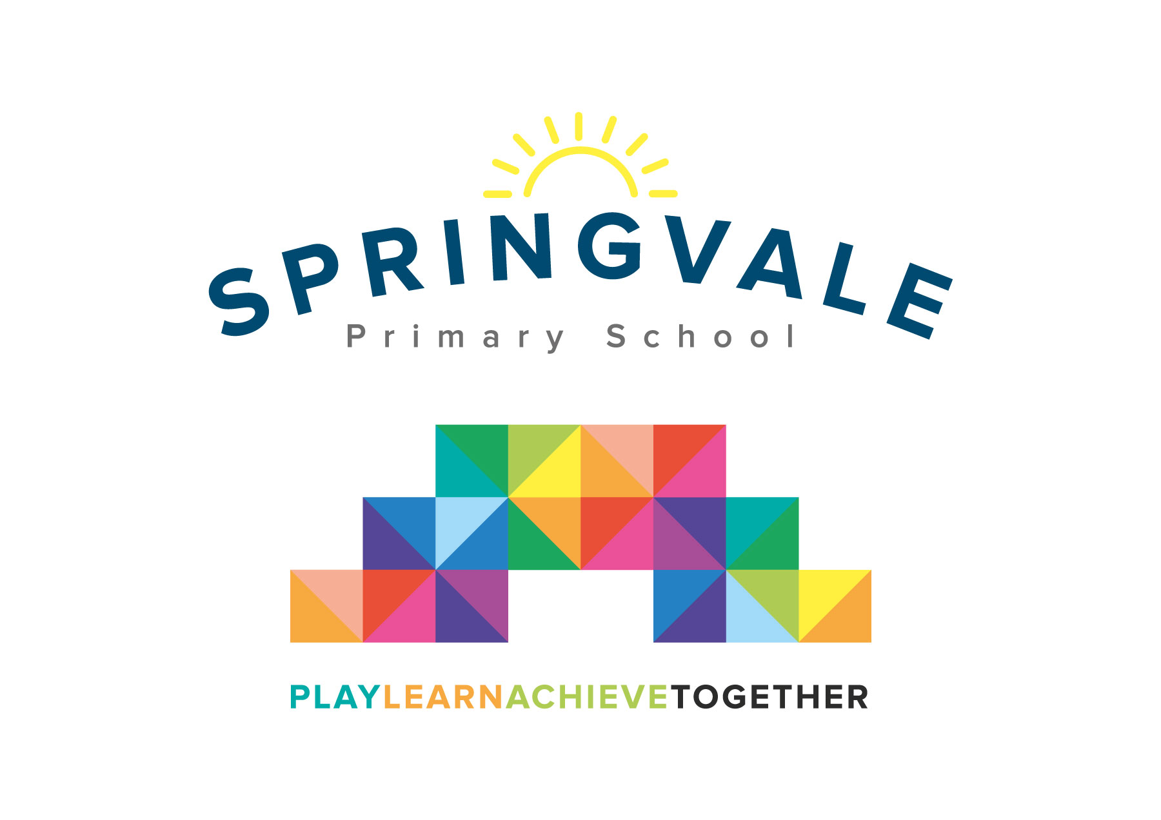

Dear Parents/Carers 23/09/2021

I have been successful in securing a free ticket for every Key Stage 2 child (Year 3-6) to visit Chester Zoo on Tuesday 16th November.

We aim to leave school at 8am (due to the long journey/rush hour traffic) and return to school for 5pm (subject to change due to traffic but we will send out updates on the day)

Younger siblings can be dropped off into the hall where they will be supervised by a member of staff until their class starts at 8:40/8:50.

Please note: There will be no breakfast club (with Mrs Cliffe) on this day due to staff being on the trip.

Children must wear school uniform with comfortable shoes/trainers and a warm coat as we will spend the majority of the day outside.

Children must bring a packed lunch (or order a grab bag) and a rucksack as they will have to carry their lunch themselves.

To cover the cost of the coaches, the trip will cost £10 per child. Please pay thorough school money. If your child is on free school meals there will be no charge for this trip but you must give parental permission via school money.

Please return the permission slip with your child’s grab bag order (if ordering one)

Miss Alderson
Year 4 teacher/Science Lead

I give permission for my child ________________________________Class______ to visit Chester Zoo on Tuesday 16th November.

Parent/carer signed___________________________________________
_____________________________________________________________________________

Childs name ________________________________Class______ Grab Bag order for the visit to Chester Zoo on Tuesday 16th November.

Please return this slip to school by Monday 8th November 2021

LUNCH ORDER

HAM CHEESE

