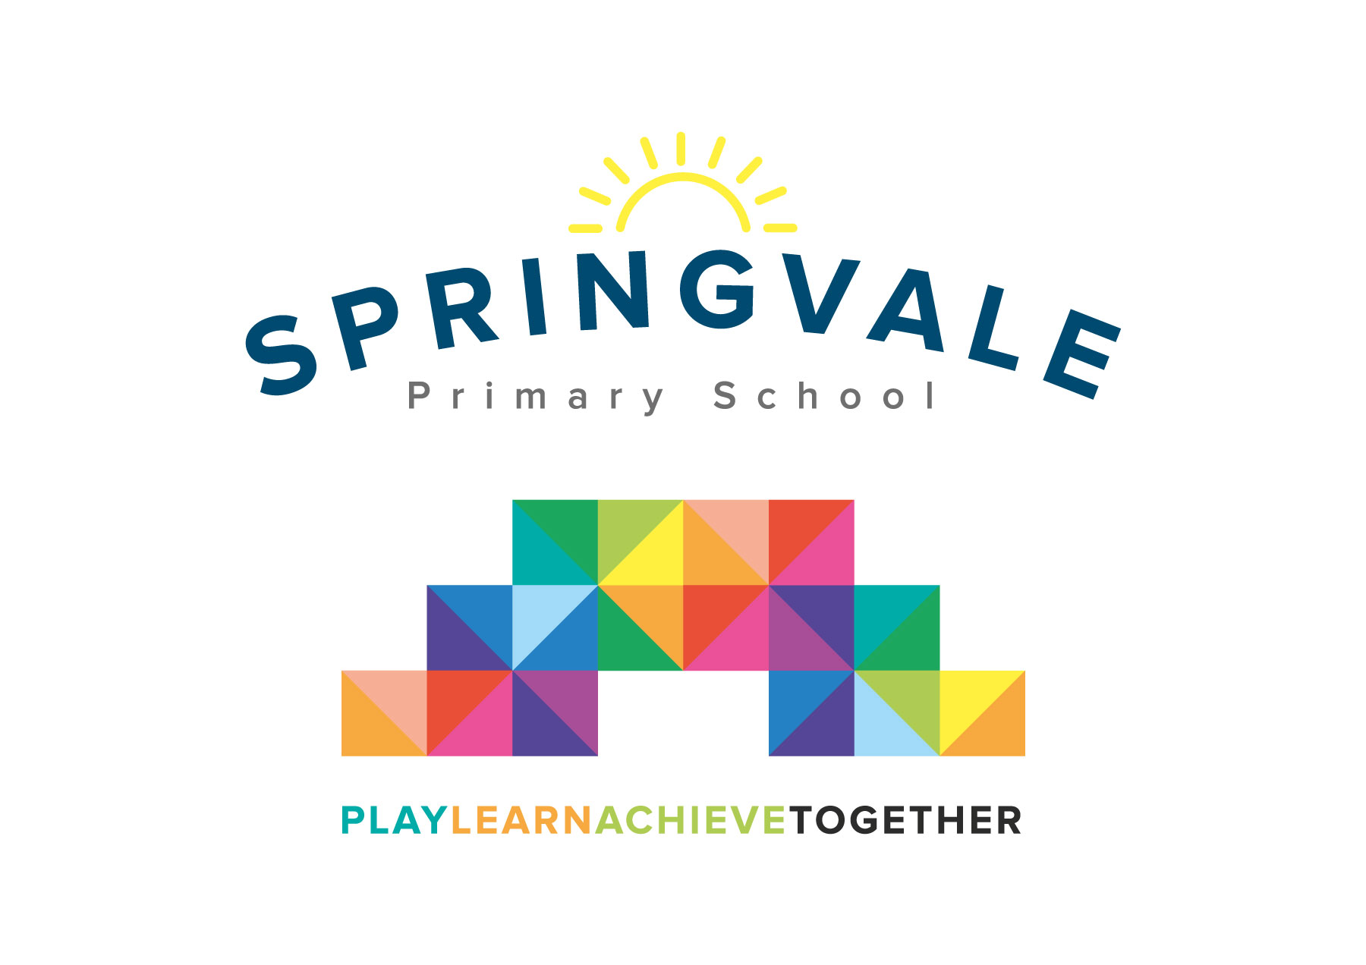
SPRINGVALE PRIMARY SCHOOL
01226 760930
Headteacher: Mr L McClure
office@springvaleprimary.org
www.springvaleprimary.org
@SpringvalePS

16/09/21

Dear Parent/Carer,

Class 1 & 2 have been offered an opportunity to take part in an exciting Science workshop on Thursday 7 October 2021. We will be visited by Wild Science who will be teaching the children about ‘Paws, Claws and Whiskers’ to tie up with our topic work. They will be bringing a variety of animals in to meet us and we can discover more about the features and habitats of these animals.

The cost for this workshop will be £4. Please note, if we do not receive enough contributions, the visit will not be able to go ahead.

You will receive an email & text notification shortly with information about how to pay for this visit on the ‘Schoolmoney’ system. Please follow the link on this message to login to your account. If you have any account login or payment queries, please do not hesitate to contact the school office.

Kind Regards,
Mrs Royston and Mrs Evans

